JOB DESCRIPTION
Concierge (Casual - £10.89 per hour)

B:Music’s mission is to inspire a love of live music, through performance, participation and learning.

Context for the role
B:Music Ltd is the music charity responsible for Symphony Hall and Town Hall, two iconic venues in the heart of Birmingham. Each year, these venues welcome over half a million people to around 800 concerts and events.
Symphony Hall and Town Hall are live music and entertainment venues, and flexibility is required around working hours, the successful candidate may on occasion be required to work outside the usual 9 – 5 office hours.

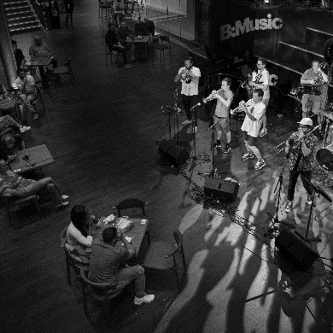

Overall Purpose
The Concierge Security Officer will provide protection and security. They will control access to the site and be the initial point of contact for customers, staff, contractors, and visitors to the site during the day. Providing a courteous welcome to those visiting B:Music; whilst actively monitoring the site via CCTV and assessing for potential security risks.

Key Accountabilities
- To provide safe controlled access and maintain a high standard of service to all guests, staff, colleagues, and visitors, demonstrate a high level of customer service with a welcoming approach, whilst sustaining a strict security policy.
- To act as a key-holder to unlock the site and secure the site.
- To ensure the site is undamaged and monitored proactively for all security and safety related occurrences. Reporting any findings in line with standard operating procedures.
- Visitor announcement and completion of inductions to contractors visiting the site.
- Provide key, fob, and radio control to appropriate staff in line with the standard operating procedure.
- To proactively operate, monitor and respond to CCTV and all relevant safety systems.
- To maintain local communication via Radio systems and telecoms and provide clear logs of any occurrences reported.
- Manage deliveries reporting expected items to the appropriate department/person. Whilst remaining vigilant of potential security concerns (hostile access or suspect packages etc).
- Conduct routine internal and external patrols and complete checks and relevant documentation. Including H&S and cleaning issue reporting and recording.
- Reporting of damage or maintenance issues.
- To monitor the security of the whole site.
- To provide radio control and respond calmly and coherently under pressure.
- Responding to visitor and customer queries either verbally or on the telephone; to a high standard of customer service.
- Work in line with ASM Terrorism Threat Response Plan and reporting process.
- Follow event day Duty Manager’s procedural requirements and support where applicable.
- Any other relevant duties commensurate with the level of responsibility of the role assigned by Event Operations Manager or other appropriate manager.
Person Specification

- Hold a current SIA Frontline Guarding or Door Supervisors Licence, current SIA CCTV licence and a First Aid at Work Qualification.
- Some experience of remaining calm under pressure and the confidence/ability to deal with difficult situations including those involving managing conflict.
- Possess clear communication skills, both verbally and in writing. With an ability to log incidents as they occur
- Possess excellent customer care skills, be professional in approach and presentable in appearance.
- Proficiency in use of Microsoft office software, and radio communications devices.
- The ability to work on own initiative as well as part of a team.
- Reliable and flexible, the requirements of the business are such that a flexible working pattern is required including working evenings and weekends and bank holidays.
- Experience in busy control room environments handling multiple channel communications.
- Previous experience preferably in the events, leisure, entertainment, or hospitality industries
- Previous counter terrorism training such as ACT awareness.
- Flexible in approach and undertake other tasks that are reasonably commensurate with this role

Desirable
Working patterns will be predominantly Monday to Sunday during the day although there may be occasional requirements to work evenings and bank holidays dependent on business needs.

Important Information

To apply, please complete the application form and you must answer the following questions

            - What are the key personal qualities that this role requires?
            - What security issues might arise whilst on duty in this role?
            - What experience of CCTV do you have?
            - Give an example of a difficult customer that you had to deal with and how you resolved the situation.

Please also complete an Equal Opportunities form and email these to recruitment@bmusic.co.uk.

Department: Front of House
Contract type: Casual contract
Salary: up to £10.89 per hour plus holiday payment
Location: Symphony Hall and Town Hall
Hours Per Week: Casual (as and when)

