JOB DESCRIPTION
Casual Bar and Events Assistant

B:Music’s mission is to inspire a love of live music, through performance, participation and learning.

Overall Purpose

To provide outstanding customer service to all customers of Town Hall and Symphony Hall by delivering quick and efficient bar service and assisting with other catering & hospitality duties as required.

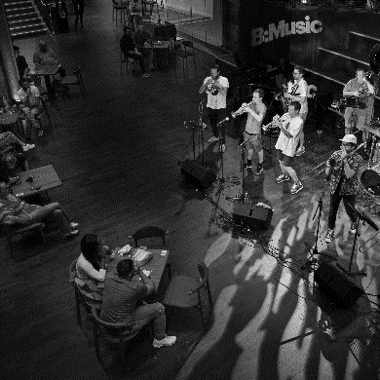

Key Accountabilities

To provide a friendly and efficient bar service at Town Hall or Symphony Hall as required, and to comply with relevant cash handling procedures.
To help with the set up and cleaning of the bar and the bar area
To maintain the cleanliness of catering areas in compliance with Health & Safety and Food Safety Regulations
To understand the importance of Data Protection when dealing with credit card payments
To fully comply with all requirements of the Premises Licence and the Licensing Act 2003
To provide food and beverage/catering services at receptions, corporate events, and other hospitality functions
To address any safety hazards which may arise by referring them to the Bar and Hospitality Managers
To assist with emergency situations, directing customers as required in the event of an evacuation
To be proactive in providing an efficient bars and food service; where possible to pre-empt customer needs and encourage use of the app and interval ordering services etc
To maintain a knowledge of the products sold and engage with customers to enhance their pre/during/post event experience.
Duties and responsibilities will vary from time to time and the post holder will be expected to perform other such duties at either venue that are reasonably comparable.

Availability
To be familiar with the products and the systems and processes in use, staff must be over 18 years of age; must be available to work regularly. Regularly is a minimum of 6 dates in every two weeks, on shifts that last for a minimum of 3 hours each, although they can be longer dependant on the event needs, of which at least 3 of the 6 dates will be Saturday and/or Sunday working

Person Specification

- Deliver excellent customer service, always
- Serve and present beverages, quickly and efficiently, meeting our standards
- Keep up to date with current promotions and new products
- Experience of providing customer service to the public
- Awareness of Health and Food Safety
- Excellent verbal communication skills and the confidence to engage with customers and promote products and offers etc.
- Experience of cash-handling using electronic systems and a willingness to learn
- Be able to work as part of a team as well as on own initiative
- Smart, reliable, and well-presented.

Reporting to: Head of Food and Beverage
Department: Food and Beverage
Contract type: Casual
Salary: £9.50 per hour plus annual leave payment
Location: Town Hall and Symphony Hall, Birmingham
Closing Date: Ongoing
Interview Date: TBC

