JOB DESCRIPTION
Casual Technicians
(Lighting, AV, Sound & Stage)

B:Music’s mission is to inspire a love of live music, through performance, participation and learning.

Overall Purpose

Working at B:Music as a casual Technician is a great opportunity to work in two of the most iconic halls in Birmingham, Symphony Hall and Town Hall, with the added bonus of flexible shifts to fit around the other important things in life.

We are looking for enthusiastic individuals to join our team working on a casual event driven basis. As casual Technicians you will be offering technical support for some of largest touring productions, our own productions and the CBSO etc. The role involves ensuring a high standard of service is maintained and providing a safe environment for all clients and visitors to the Halls.

 | 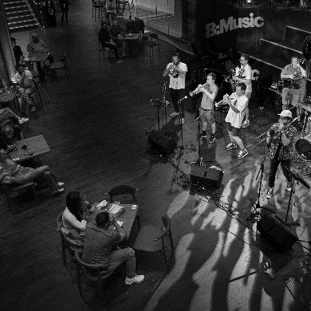 | 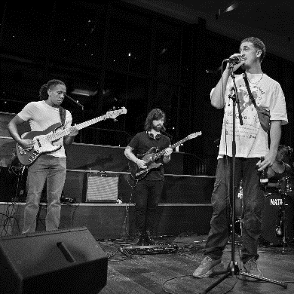

Key Accountabilities

- Ensure all technical requirements are achieved for all events
- Work in conjunction with visiting technicians and artists and liaise with internal Technicians, Production etc., reacting positively to any last-minute changes.
- Act as Stage Manager, Lighting Technician, Sound Technician, or any other role required (including TH Seating Supervisor).
- Ensure all relevant event paperwork and check sheets are completed as appropriate and any issues are reported.
- Maintain all equipment and report all faults to the appropriate individual and record all Health and Safety issues correctly.
- Working on the changeovers between each event (sometimes overnight) to configure the venue for the client’s needs.
- Assist the Technicians to deliver Health & Safety briefing to visiting crew etc.
- Communicating and providing assistance to other departments and the touring production with their operational requirements within the Halls
- Supporting visiting crew and contractors to ensure compliance with venue policies and standards.
- Supervise other team members, including other casual and freelance technicians, volunteers, apprentices, work experience etc.
- Duties will vary from time to time and the postholder will be expected to perform other such duties that are reasonable comparable.
Person Specification

Essential

- At least 1 years’ experience within the technical department of a similar organisation
- Ability to take on and accept responsibilities, especially when acting as Stage Manager
- Comprehensive understanding and proven experience of sound and light operation, rigging, fault finding and maintenance
- Demonstrable experience in competent operation of analogue and digital sound desks including Midas M32
- Working knowledge and experience of lighting design, rigging, operation, fault finding and maintenance
- Practical and competent operation of the Avolites Quartz and Sapphire lighting desks
- Professional and customer focused with excellent time management skills
- Ability to work on own initiative and work as part of a supportive and engaged team.
- Physically fit , as physical work and manual handling is involved
- Well presented (some uniform provided)
- A willingness to learn new skills
Desirable

- First aid at work
- IPAF/PASMA training
- Ladder Safety Training
- Pyrotechnics Safety Awareness Training

Reporting to: Technical Manager
Department: Operations
Contract type: Casual
Salary: £9.50 - £11.34 dependent on the job role
Location: Symphony Hall and Town Hall, Birmingham

Successful applicants will be invited to join our casual database, giving them the opportunity to sign up for event-based shifts. This is a casual, event-based vacancy and will include evening, weekend, and public holidays work.
Important Information
We are looking for people urgently and will look to interview candidates over the next few weeks, so please respond as soon as you can.

Closing date: See above, this is an ongoing vacancy, the sooner you apply, the sooner can interview

