JOB DESCRIPTION
Ticket Sales Assistant - Casual (£9.50 per hour)
B:Music’s mission is to inspire a love of live music, through performance, participation and learning.
Overall Purpose
To provide an efficient booking and information service for all customers of Performances Birmingham Ltd, both via counter sales and over the telephone, in line with procedures, standards and targets.

 | 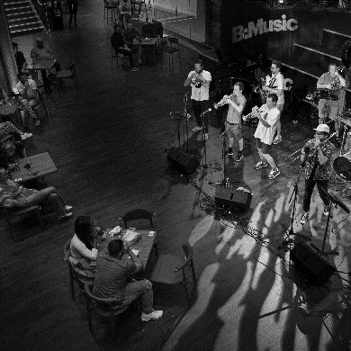 | 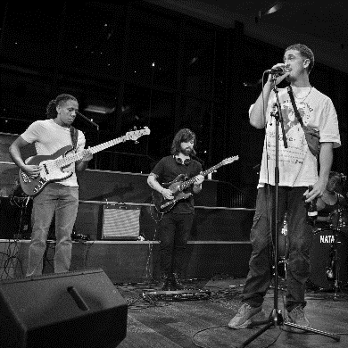

Key Accountabilities
- Accurately process ticket bookings and deal with customer queries in person and over the telephone, using the Box Office ticketing system and other software packages.
- Process subscription bookings accurately as required.
- Sell THSH Membership Packages to customers, proactively upselling where appropriate.
- Process exchanges, upgrades, and refunds accurately and undertake any other associated duties.
- Process parking requests at Symphony Hall for disabled customers in accordance with defined procedures.
- Assist with batch print and ticket dispatch by enveloping tickets as required.
- Record required customer information, ensuring that existing records are checked and updated at point of sale and amendments to the mailing list are processed as necessary.
- Provide customer service in a friendly and professional manner, reporting any relevant issues or complaints to the Manager.
- Handle cash and reconcile income at the end of a sales session in accordance with financial procedures.
- Act as Key Holder for designated Town Hall events
- Answer customer emails in a professional and accurate manner
- Adhere to Company health, safety & environmental policies and always maintain a safe working environment
- Undertake any other duties commensurate with the responsibilities of this role.

Person Specification

- Educated to GCSE level or equivalent and can demonstrate numeracy and literacy.
- Experience of providing high levels of service to customers in person or over the phone
- High level of accuracy and attention to detail.
- IT and internet literate.
- Experience of ticketing systems desirable.
- Interest in the Arts and Entertainment.

Reporting to: Head of Box Office
Department: Box Office, Sales and Marketing
Contract type: Casual
Salary: £9.50 per hour
Location: Symphony Hall, Birmingham
Closing Date: 13th September 2021
Interview Date: TBC

